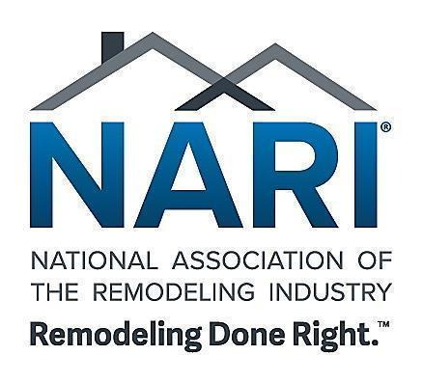
FOR IMMEDIATE RELEASE

Contact: Anne Marie Gerhardt
Communications Manager
Phone: (847) 298-9200
Email: agerhardt@nari.org

NARI Launches SecureFuture 401(k) Plan, a New Member Benefit to Help Remodeling Businesses Compete for Talent
The organization announces a collaboration with Traphagen CPAs & Wealth Advisors to provide a streamlined way for its members to offer employee 401(k) benefits.
WHEELING, Ill., August 26, 2026 — The National Association of the Remodeling Industry (NARI) today announced a new member benefit, the NARI SecureFuture 401(k) Plan, a professionally managed pooled employer plan (PEP) built specifically for the remodeling industry. The plan gives NARI member businesses, many of them small and mid-sized firms, a straightforward path to offering employees a competitive retirement benefit without taking on the administrative burden of running a plan themselves.
NARI delivers the benefit through a partnership with Traphagen CPAs & Wealth Advisors, which manages investments. Under the plan, employers handle only three tasks: selecting service providers, setting up payroll deductions, and collecting year-end data. The provider team manages plan design, investment oversight, eligibility tracking, enrollment support, participant education, withdrawal and loan processing, compliance reporting, and ongoing plan maintenance. The plan connects directly to more than 125 payroll providers to simplify setup and gives employees access to a dedicated website, a mobile app, the OnTrack planning tool, and Managed Advice, a personalized, goals-based investment management service.
The new benefit reflects a broader shift in how NARI supports its members. Beyond its traditional benefits, NARI is focused on equipping remodeling business owners with the practical tools and information needed to run stronger companies. A retirement plan designed for the realities of a remodeling business, where crews are often small and margins are tight, directly addresses the challenges of competing for skilled labor.
“Remodeling companies want to take care of their people, just like any other business, but many owners don’t have the time or an HR department to set up a 401(k) on their own,” said Lisa Sallstrom, NARI’s chief executive officer. “This plan allows a small remodeling firm to offer the same high-quality retirement benefit as a national builder—without adding another job to the owner’s plate. That’s what member value should look like.”
NARI's core purpose is to strengthen professionalism in the remodeling industry. Retaining and investing in reliable, knowledgeable, and experienced staff helps achieve that purpose. According to Transamerica Institute®, 89% of surveyed workers value a 401(k) or similar retirement plan, and 80% say retirement benefits offered by a prospective employer are a major factor in deciding whether to accept a job offer.¹
"Retaining skilled labor is one of the biggest challenges for our members," said Jonathan Kelly, CRA, NARI board president. "A benefit like this offers a new reason for a talented project manager or skilled tradesperson to build a career with a NARI member company." NARI member businesses interested in joining the SecureFuture 401(k) Plan can contact Carolyn Lawrence at membership@nari.org or visit nari.org for more information.
¹ Emerging From the COVID-19 Pandemic: The Employer's Perspective," nonprofit Transamerica Institute, August 2022. Transamerica Institute® is a nonprofit, private foundation funded by contributions from Transamerica Life Insurance Company and its affiliates. For more information, visit transamericainstitute.org.
About NARI
The National Association of the Remodeling Industry (NARI) is the premier association representing the remodeling industry, committed to advancing professionalism and fostering consumer confidence. NARI members adhere to a strict Code of Ethics and uphold the highest standards of quality and integrity, ensuring Remodeling Done Right™. Since the 1960s, NARI has been dedicated to advancing the remodeling profession and elevating the homeowner experience through education, advocacy, and a shared commitment to excellence. Find a trusted NARI professional at remodelingdoneright.com. For more information, visit nari.org or call 847-298-9200.
####

