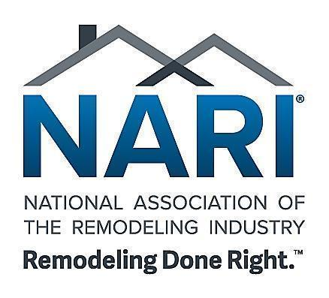
FOR IMMEDIATE RELEASE

Contact: Martha Lara
Director of Marketing & Membership
Phone: (847) 298-9200
Email: mlara@nari.org

Top Remodeling Projects in the Nation Honored: NARI Announces 2026 National Remodeler of the Year (RotY®) Winners

Wheeling, IL, May 4, 2026 — The National Association of the Remodeling Industry (NARI) proudly announces the 2026 National Remodeler of the Year (RotY®) Award winners, recognizing the most innovative, expertly crafted, and transformative remodeling projects across the United States.

Selected from a highly competitive pool of entries, these award-winning projects exemplify the pinnacle of design, craftsmanship, and project execution in today’s remodeling industry. Each winner has demonstrated exceptional attention to detail, creative problem-solving, and a commitment to delivering outstanding results for homeowners.

“The National Remodeler of the Year winners truly represent the best of the best,” said Tracy Wright, CAE, CNAP, NARI Co-CEO. “These projects showcase not only incredible craftsmanship, but also the innovation, professionalism, and dedication that define NARI members and elevate the remodeling industry as a whole.”

Recognizing Excellence Across the Industry
The RotY Awards are NARI’s most prestigious national honors, judged by industry experts and peers through a rigorous evaluation process. Projects are assessed on:
- Design innovation
- Problem-solving and functionality
- Aesthetic appeal
- Craftsmanship and execution

This year’s competition was especially strong, with hundreds of submissions nationwide. From those entries, more than 159 Regional winners and over 40 National winners were selected—collectively representing more than $138 million in remodeling projects. To see the full list of winners, visit nari.org/NationalRoty.

In addition to project-based honors, NARI also recognized outstanding individuals, companies, and chapters through its Achievement Awards, which celebrate excellence beyond the jobsite. These awards highlight leadership, innovation, community impact, workforce development, and contributions that strengthen the remodeling industry as a whole.

Achievement Award recipients exemplify the values that define NARI—professionalism, integrity, and a commitment to advancing the industry—demonstrating that success is measured not only by projects completed but also by the positive impact made on teams, communities, and the future of the trades.

Celebrating the Industry’s Finest
The 2026 National RotY winners and Achievement Award recipients were honored during the Evening of Excellence at the NARI Annual Conference—an event dedicated to celebrating the achievements and impact of remodeling professionals who are shaping the future of the industry.

Together, these awardees represent the full spectrum of excellence within NARI—from exceptional project execution to leadership, innovation, and industry advancement.

These award-winning companies and individuals exemplify what it means to deliver Remodeling Done Right™—combining technical expertise, ethical business practices, and a deep commitment to client satisfaction.

Setting the Standard for Remodeling Nationwide
Each winning project not only transforms a home, but also reinforces the value of working with qualified professionals who adhere to NARI’s strict Code of Ethics and high standards.

From stunning kitchen transformations to complex whole-home renovations, and from workforce development leaders to industry advocates, this year’s awardees demonstrate how NARI members continue to raise the bar for quality, safety, innovation, and professionalism across the remodeling industry.

The 2026 Achievement Award recipients are:
Category | Name of Nominee:
Chapter Community Service | NARI Pacific Northwest
Chapter Community Service | NARI of Greater Charlotte
Chapter Community Service | Austin NARI
Chapter Community Service | NARI Atlanta
Chapter President | Brett Clarke
Distributor of the Year | Ferguson Home
Mary Busey Harris, CAE Professionalism | Kim DiMaggio
Peter H. Johnson Image | Gordon B. Reese III
Workforce Development | NARI Madison
Workforce Development | Austin NARI
Workforce Development | Susan Raisanen
Workforce Development | Melany Fuentes
Workforce Development | NARI of Central Ohio
Workforce Development | NARI Milwaukee
Workforce Development | Bethany Martin
Lifetime Achievement | Jason Hensler
Lifetime Achievement | Don VanCura
Chapter Excellence | NARI of Greater Charlotte

# # #

About NARI
The National Association of the Remodeling Industry (NARI) is the premier association representing the remodeling industry, committed to advancing professionalism and fostering consumer confidence. NARI members adhere to a strict Code of Ethics and uphold the highest standards of quality and integrity, ensuring Remodeling Done Right™. Since the 1960s, NARI has been dedicated to advancing the remodeling profession and elevating the homeowner experience through education, advocacy, and a shared commitment to excellence. Find a trusted NARI professional at remodelingdoneright.com. For more information, visit nari.org or call 847-298-9200.

